Steam Installation Instructions.

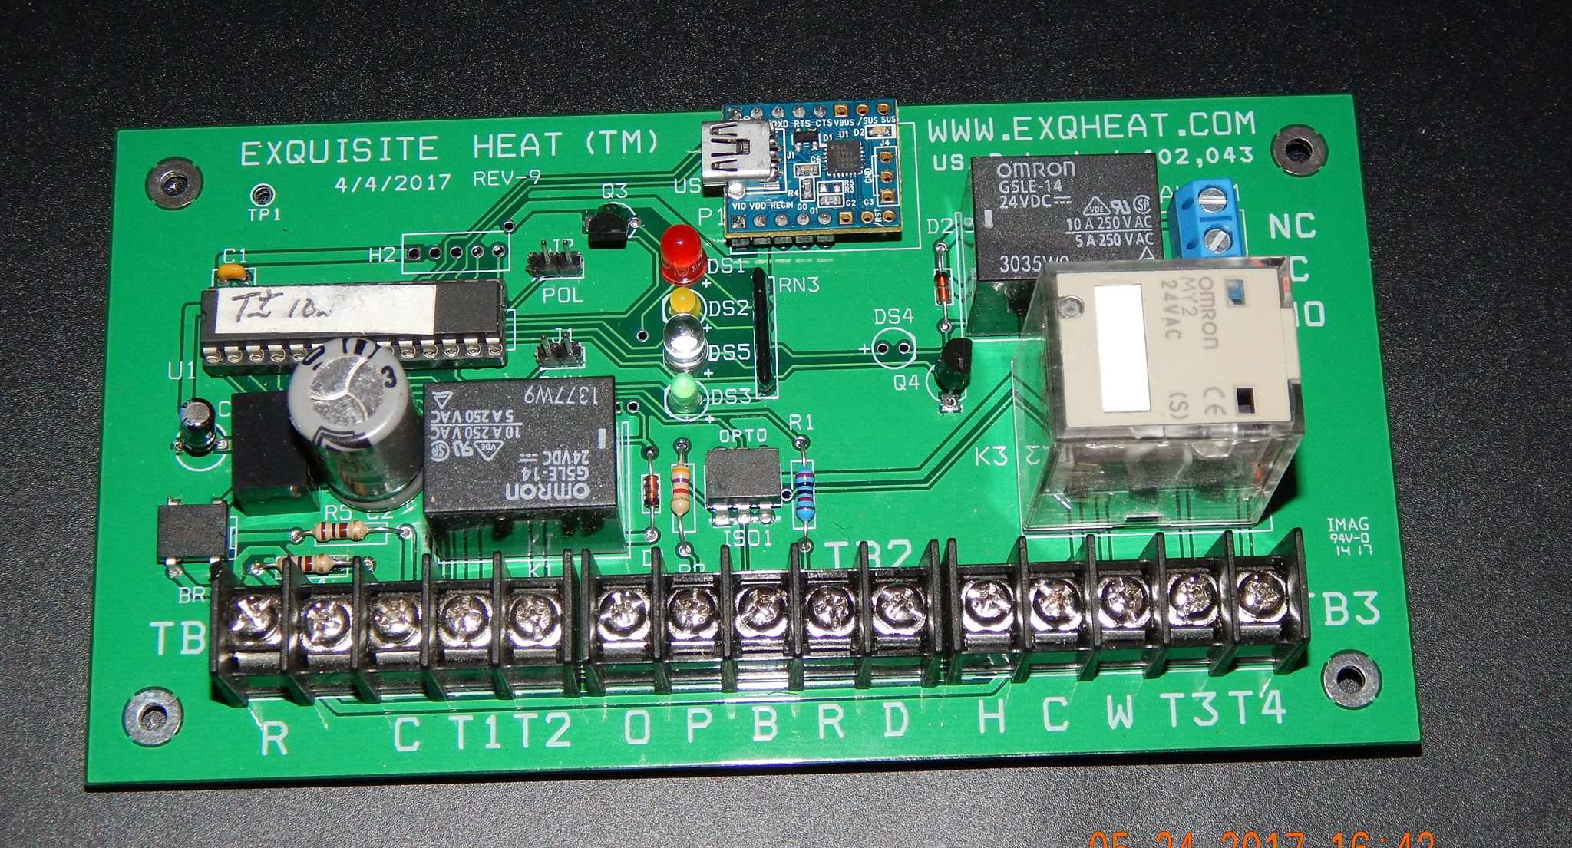

Welcome to Exquisite Heat Rev 9

Before installation turn off the boiler power source at the main power circuit panel, or boiler safety switch, if Main Panel is not available. You should mark the Main Panel boiler breaker with a marker for future service visits.

Use your multimeter to assure there is no 120Vt source at the boiler. If improperly wired at the panel, there will be voltage somewhere near the boiler. Be warned. It can happen. Properly wired panels should disconnect the load voltage to the boiler.

Wiring

Supplies: 2 wire thermostat wire 18 gauge. White wire 18-22 gauge needed for sensor runs in apartments. Brown 18 gauge 2 wire for transformer wire runs. Wire stripper, wire ties ( do not wrap wires to hot steam piping) electrical test meter, wire finder tool, staple gun, wire (18 gauge 2, 4, 8 wire) , screw drivers, head lamp, electrical gloves, eye protection, and electric drill with hammer feature ( for concrete anchor mounting of control box) installation and make sensor wire runs, ladder for overhead wire runs. A temperature measuring tool is helpful to calibrate thermostat settings to room temperature.

A helper employee can be used to help with long wire sensor location, basic install wiring, and the ladder, run for tools, parts and coffee. A labor saving tip: locate a non used telephone cable that has been abandoned to wire thermostat remote sensor from Exqheat to an upper level temperature sensor apartment. Confirm wires with wire finder tool.

The 8 wire cable runs from the controller to a convenient location on the boiler. Two wire sub connections will come to this point. You can wrap this set of connections after installing sensor wires and burner connections.

(Oil Steam systems) If there is a burner connection to the hot water aquastat, leave this Intact to fire domestic hot water needs..

Blue & White for TT at the burner back to T1 &T4 on Exqheat Controller. Install jumper from T2 to T3.

Black & Yellow for the Hartford Loop sensor on steam boilers back to B & R on the Exqheat Controller.

Orange & Brown for domestic hot water sensor, if needed back to D&H on Exqheat Controller. If not used keep installed resistor in place.

Thermostat 4 wire thermostat connection: Thermostat C to C and R to R on the Board. Thermostat W to W on control board. Keep the jumper R to Rc in tact. The dry closure in the thermostat at R and W, will trigger 24 volt relay closure T3 & T4 on the exqheat board large relay on the right.

(Gas Steam systems) : 4 wire cable to boiler.( 8 cable if domestic hot water sensor is used) Interrupt one power wire to ignition module. Bring this in series connection wire back to T1 and T4. Place a jumper between T2 and T3.

POWER

(Load) power should not be connected from the transformer until all other system connections are made and carefully checked and rechecked.

Power for the board and thermostat must come from a separate/independent AC24volt 40VA transformer. Power polarity is important. Wire C on transformer to C at the thermostat and C on the Exqheat Controller. This will insure polarity of circuits in both the Thermostat and Controller.

Green wire from W on thermostat to W on the Exqheat Controller. This will provide power to the Thermostat relay on the Controller. Closure of both the Cutoff relay at T1 & T2 and the Thermostat relay at T3 & T4 will fire the boiler. T1 & T2 will open when the controller fire time limit is reached.

The Red light on the controller will light indicating the boiler is cut off. The light will go out when the boiler is to fire.

When the thermostat is calling the Yellow light will light and the red line will be visible on the Thermostat relay to the far right of the controller.

The Green light indicates proper software operation when flashing on and off. If green light is flashing quickly, it is starting up and has a one minute delay to start. This prevents sudden surges to burner motor on start up.

Hartford Loop Temperature sensor provides a shut down if the water level/fill control fails, and the boiler is running out of water. Temperature sensor is attached, and wrapped with insulation, on the boiler side of the Hartford Loop below the close nipple between the return water and bottom of the Hartford Loop. Location and temperature setting will vary with different boiler systems. Factory setting is 200 F. This wire is connected to B & R on the Exqheat Controller. This alarm temperature can be reset to suit installation in Terminal Laptop software or on request for a new chip from the factory. Steam level will reach the temperature sensor and shut down the boiler for service. Service is returned after repair by repowering the controller. This may require call for a service for Exqheat Controller. Service is Cheaper than a new boiler.

D & H serve as connections for domestic hot water temperature sensor attached to the domestic hot water pipe leaving the boiler, if there are not other methods of controlling domestic hot water temperatures. There may be a separate aqua-stat to control DHW boiler temperatures, mixing valves, or separate storage with its own aqua-stat. If the DHW temps are already being controlled, there is no need for using this D&H sensor. If D and H are not used for domestic hot water, be sure to have a 20K resistor connected across these terminals. Resistor across D&H must be removed if domestic hot water is to be controlled by Exqheat controller. This sensor has a separate temperature setting in the Exqheat control for DHW supply during non-heating periods to maintain domestic hot water supply to the building. Remember that temperature at the faucets above should not be 110 degrees to assure avoiding the risk of scalding temperatures to the end user. If you can hold your hand to the hot water from building faucets, this should be safe. Adjust DHW temp in Terminal as needed, or call factory for an adjusted DHW temp setting.

BY Pass Switch is located on the outside of the cabinet. This switch is for control failure and service personnel. The switch is wired between T1&T2. The on position creates a bypass of the cutoff relay. The Off position allows the cutoff relay. The switch should be labeled Control On, Control Off for customer convenience. The bypass is activated by “Control Off” position of the switch by connecting T1 to T2 to indicate the bypass and the boiler will run on thermostat.

Should there be a “no heat call”, the problem is simple to identify. Have the operator check the lights on the control.

If the red light is on, the controller may be in a break time mode.( usually 15-20 minutes)

The green light should be flashing on and off.

The yellow light is on indicating a call for heat from the thermostat.

Call the service company on the telephone or 914-588-4791 for help.

If the control has failed switch the bypass to the “Control Off” position. If the boiler fires control service is needed. Leave the bypass switch in the “Control Off” position until service is provided. If the boiler does not fire, call for boiler service. Be sure to place switch in control ON after boiler service is completed.

THERMOSTAT: Honeywell 8000 Vision series with remote sensor (RF wireless available). One well placed will keep things simpler. Sensor can be relocated for better data.

For private homes remote sensors can be useful for more representative heat loss locations. An existing thermostat can also be used to conserve on expense for new thermostat. If existing thermostat is a dry closure attach to C&W on thermostat relay on the Exqheat Board. If W from the thermostat is powered, attach to W on thermostat relay. Observe polarity.

Remote thermostat Sensor location: Upper apartment room, not near the kitchen or windows that may be opened. The hall between bedrooms outside a closet makes a suitable sensor location. Read sensor instructions for location and wiring. Remind folks not to paint the sensor, or tell anyone they know about the sensor. They will be a popular neighbor in the middle of the night. You want to locate the sensor on the top two floors of the building, with a cooperative family. The landlord may be of help on this one. If using a wireless sensor, make sure to test the sensor for proper reception at the thermostat. If distance is a problem, you can locate the thermostat to secure location closer to the sensor for thermostat to share a clear reliable signal. Be sure to use the Duracell Optimum batteries. These batteries should be changed during annual fall service calls. This is a good time to tell the Owner about annual visits. You are well advised to get the sensor apartment residents telephone number in order to make your appointment to visit for a battery change.

Some boilers do not have a 24 volt low voltage TT control. Riello is one. Some boilers will require a low to high voltage relay in series to bridge the low voltage gap to Exqheat.

Inform the owner of the need for annual service calls. $75-100 should cover the visit. This is an opportunity to get leads for other folks who need better control for their heating.

Extra services needed, will be more for parts and time.

1. Assure the software is up to date and operating properly.
2. Basic safety check to check boiler control settings and proper operation.
3. Assuring wiring integrity against sabotage by other services.
4. Change of Batteries in thermostat and remote wireless sensors.
5. Blow down water level controls.
6. Check proper operation of condensate tank fill controls.
7. Adjust thermostat programmed temperature limits to comfort levels in the building.

If you find these instructions in need of editing and revision, feel free to contact us at:

[Exquisiteheat@yahoo.com](mailto:Exquisiteheat@yahoo.com). If you have any final questions, feel free to call us at 914-588-4791. 2-23