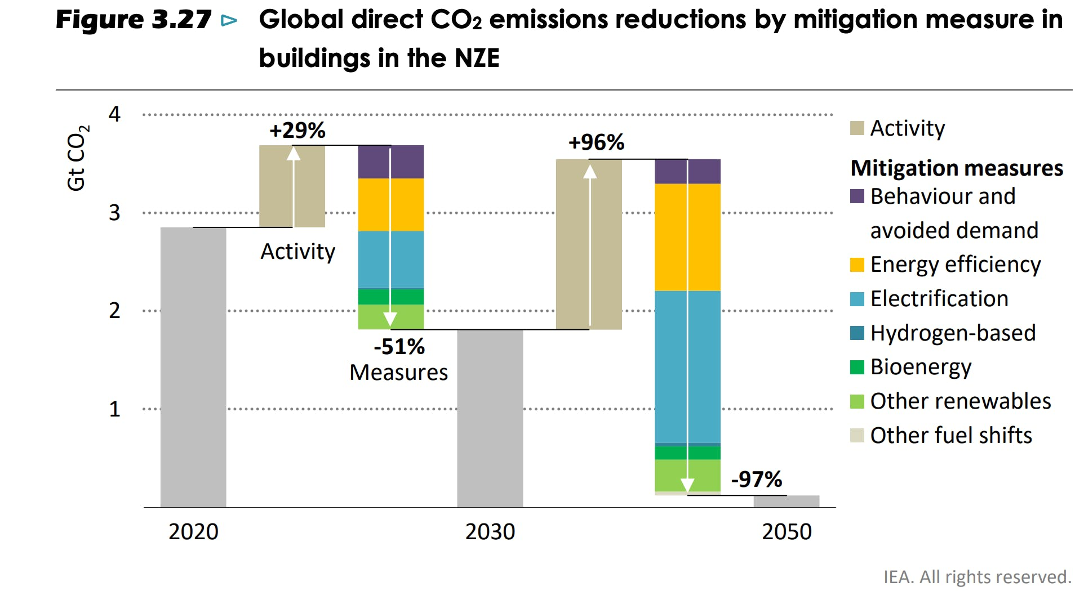

Here's their full target list for buildings:

1. Retrofit >85% of buildings to zero‐carbon‐ready level by 2050 (and ensure that zero‐carbon‐ready compliant building energy codes are in place by 2030 at the latest)
2. Build 100% zero‐carbon‐ready new building construction by 2030
3. Scale up heat pump production by 10x by 2050
4. Install solar thermal on 1.2B buildings by 2050
5. Adjust our residential energy heating and cooling setpoints to avoid 14% of demand by 2050
6. Increase appliance efficiency by 40% by 2050
7. Sell only LED lighting by 2025
8. Provide electricity and clean cooking to 9.7B people by 2050
9. Install 7500 TWh of distributed solar PV generation on buildings
10. Install 3.5B privately owned EV chargers in buildings

Note that the timelines may be out of date now, given the new IPCC research.

Regardless: We as an industry must unite around this list.

*"Any delay in reaching 2.5% of annual retrofits by 2030 would require such a steep subsequent ramp up as to make retrofitting the vast majority of buildings by 2050 virtually impossible."*

*​*

*"There are multiple milestones on the way to global net-zero emissions by 2050.****If any sector lags, it may prove impossible to make up the difference elsewhere."***