Hydronic (hot water boiler) Installation Instructions.

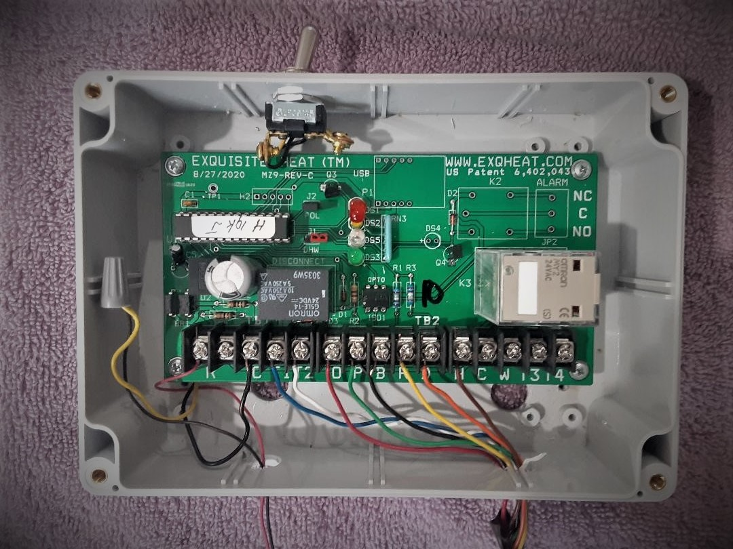

Welcome to Exquisite Heat Rev 9

Before installation turn off the boiler power source at the main power circuit panel, or boiler safety switch. You should mark the Main Panel boiler breaker with a marker for future service visits.

Use your multimeter to assure there is no 120Vt source at the boiler. If improperly wired at the panel, there will be voltage somewhere near the boiler. Be warned. It can happen. Properly wired panels should disconnect the load voltage to the boiler.

Wiring for Hydronic (circulating Hot Water) Boiler

Supplies:

2 wire white wire (22 gauge) needed for sensor runs in apartments. . A labor saving tip: Locate a non used telephone cable that has been abandoned, to wire thermostat remote sensor from an upper level temperature sensor apartment to thermostat sensor connections. If wire run is not possible, wireless sensor can be installed within range of thermostat location.

24VAC40 Transformer for power to thermostat and controller..

4 wire Brown thermostat wire 18 gauge for thermostat run.

2 wire Brown 18 gauge wire for 24VAC transformer wire runs.

8 wire 18 gauge wires for main wire run from Exqheat control to boiler area. This wire can be used for all wires needed at the boiler.

2 for TT at the burner. (blue/white)

2 for the Hot water supply sensor or Hartford Loop sensor on

steam boilers. (yellow/black)

2 for domestic hot water sensor, if needed. (orange/brown)

You may not use all the wires, but the extras may be useful as you proceed with your installation and maintenance. Using the prescribed wire color guide in picture above will make wiring accuracy more convenient.

Tools and supplies

Wire stripper, wire ties ( do not wrap wires to hot steam piping) electrical test meter, staple gun, screw drivers, head lamp, electrical gloves, eye protection, and electric drill with hammer feature ( for concrete anchor mounting of control box) installation and make sensor wire runs, ladder for overhead wire runs.

A helper employee can be used to help with long wire sensor location, basic install wiring, and the ladder, run for tools, parts and coffeeThe 8 wire cable runs from the controller to a convenient location on the boiler. Two wire sub connections will come to this point. You can wrap this set of connections after installing sensor wires and burner connections. All wires should travel and be attached to supports out of reach and not near hot pipes from steam boilers.

(Oil hydronic systems) connect the circulator relay 24 volt low voltage TT in parallel to your eight wires (red and green wire) to the O & P terminals on the Exqheat board. This will sense thermostat data from the thermostat through the boiler circulator relay On multi zone controls, take the low side 24 connection (where thermostat wire is connected on top of the zone relay) from a chilly zone that is not normally set back by a programmable thermostat. Some boilers do not have a 24 volt low voltage circulator control. Riello is one. These boilers will require a l high to low 24 voltage relay in series to bridge the gap for Exqheat.

Power: Attach (2 wire thermostat cable) red wire for power supply from the R load side of the 24volt VAC transformer to Exqheat controller R terminal and the thermostat Rc input. ( Remove the jumper from RC to R on thermostat)

The white wire C from transformer to C on Exqheat controller and C on the Thermostat. Controller and the Thermostat in polarity synchronization will assure smooth circuitry.

This transformer wiring can be made at the convenience of the installer. R and C can come to either Thermostat or Exqheat from transformer then on to either unit saving the inconvenience of double wiring from the transformer. R (load) power at the transformer should not be connected until all other connections are made and carefully checked and rechecked.

B & R ( black and yellow 18 gauge) for the temperature sensor attached to the Boiler Hot water supply pipe leaving the top of the boiler, to measure the exit temperature from hot water boiler. (Hydronic boilers) Attach the supplied temperature sensor two inches up the Hot water supply pipe where it leaves the boiler. Run a two wire up to the (black and yellow) wires on the Exqheat 8 wire cable. Make sure to wrap the sensor against the pipe with insulating materials, securing with wire ties.

T1-T2 dry cut off relay (8 wires blue and white) to 24 volt burner TT connection in series with the low voltage burner safety loop. Be sure to check all circuits with a multi meter to assure you understand the needs for adaptation. Always check the TT voltage at the boiler before making connections. Be sure to check all series circuits with your multimeter, to assure proper series circuit for safety loop to T1-T2. Test that boiler is not operating when T1 and T2 is open.

D & H (orange and brown wire) serve as connections for domestic hot water temperature sensor attached to the domestic hot water pipe leaving the boiler. There may be a separate aqua-stat to control DHW boiler temperatures, mixing valves, or separate storage with its own aqua-stat.

If the DHW temps are already being controlled, there is no need for using this D&H sensor If D and H are not used for domestic hot water, be sure to have a 19K resistor connected across these terminals at the controller.(supplied and installed) Remember that temperature at the faucets above should not be above 110 degrees to assure avoiding the risk of scalding temperatures to the end user.

Control Terminals C, W, T3, and T4, are reserved for Steam Boiler applications.

.

Gas boilers: (4 wire cable) interrupt the 24 VAC power to ignition module wire. Bring this wire back to T1 and T2.

THERMOSTAT: With Honeywell 8000 Vision series with remote sensor (RF wireless available) you can use up to three sensors for averaging if needed. Look at it carefully. One well placed sensor will keep things simpler. A separate 24vac40va transformer is required for power to the thermostat and controller.

For private homes remote sensors can be useful in more representative heat loss locations. An existing thermostat can also be used to conserve on expense for new thermostat.

Remote thermostat Sensor location: Upper apartment room, not near the kitchen or windows that may be opened. The hall between bedrooms outside a closet makes a suitable sensor location. Read sensor instructions for location and wiring. Remind folks not to paint the sensor, or tell anyone they know about the sensor. They will be a popular neighbor in the middle of the night. You want to locate the sensor on the top two floors of the building, with a cooperative family. The landlord may be of help on good location. If using a wireless sensor, make sure to test the sensor for proper reception at the thermostat. If distance is a problem, you can locate the thermostat to secure location closer to the sensor and thermostat to share a clear reliable signal. Be sure to use the Duracell Optimum batteries. These batteries should be changed during annual fall service calls. You are well advised to get the sensor apartment residents telephone number in order to make your appointment to visit for a battery change.

If you find these instructions in need of editing and revision, feel free to contact us at:

[Exquisiteheat@yahoo.com](mailto:Exquisiteheat@yahoo.com). If you have any final questions, feel free to

call us at 914-588-4791. We can zoom