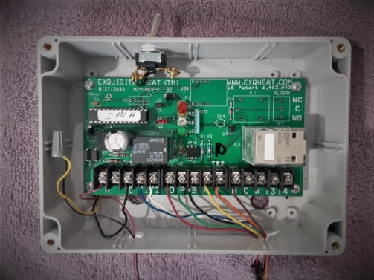 Exquisite Heat Steam Boiler reset

For Service:

1. Turn Control on off switch to OFF. This will remove the control from the boiler by closing T1 and T2.
2. When service is completed, reactivate the Control (switch to ON)
3. The Green light will flash On and Off indicating software operation.
4. The Yellow light will indicate a call for heat from the thermostat.
5. The Red light will go out when the boiler fires. The light will come on when the boiler is disconnected by the control cut off relay (black) when the calculated fire time has expired, or thermostat is satisfied.The boiler will remain off If called by thermostat the boiler will refire provided the demanded break is expired.
6. Fire times are computed from thermostat activity during the previous hour. As thermostat activity increases and decreases, the controller increases and decreases the calculated fire time setting proportionally. Low pressures will be normal. Minimum fire times are set to assure recovery to entire system. Maxmum times are set to satisfy a cold start to fill the system with steam. Breaks between cycles are 15 minutes to allow the steam heat to radiate to the room.
7. Recorded reduction in fuel use range from 5-25%. The first goal for Exquisite Heat is comfort in all areas of the structure. Fuel savings are achieved by achieving that comfort at lower fire times, requiring less fuel. 2-23

Exquisite Heat ww.exqheat.com

914-588-4791 [exquisiteheat@yahoo.com](mailto:exquisiteheat@yahoo.com)