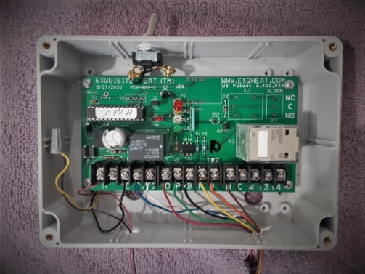 Exquisite Heat Hydronic Boiler reset

For Service:

1. Turn Control on off switch to OFF. This will disconnect power to the controller and remove the control from the boiler. This connection is placed between R and R on the Exquisite Heat Controller.
2. When service is completed, repower the Control (switch to ON)
3. The Green light will flash rapidly (spurts of three) for one minute to avoid surge damage to the burner.
4. After one minute the green light will change to steady blink on and off. This indicated the software is working properly.
5. The yellow light will indicate a call for heat from the thermostat.
6. The red light will go out when the boiler fires. The light will come on when the boiler is disconnected by the control cut off relay (black) when the calculated high limit has been reached. The boiler will remain off until the temperature of the water leaving the boiler reaches its calculated differential low limit. If called by thermostat the boiler will fire cycle to seek the calculated high limit.
7. High limit temperature calculations are computed from thermostat activity during the previous hour. As thermostat activity increases and decreases, the controller increases and decreases the calculated high temperature setting proportionally.
8. Lower than limit water temperatures circulated at 40-60% of the time to provide precise temperature water to the entire system for even comfort at minimum temperatures to achieve that comfort. Recorded reduction in fuel use range from 5-25%. Differences in these returns are dependent upon th building envelope and system operation before control installation. The first goal for Exquisite Heat is comfort in all areas of the structure. Fuel savings are achieved by achieving that comfort at lower temperatures, requiring less fuel. 2-23

Exquisite Heat ww.exqheat.com

914-588-4791 [exquisiteheat@yahoo.com](mailto:exquisiteheat@yahoo.com)